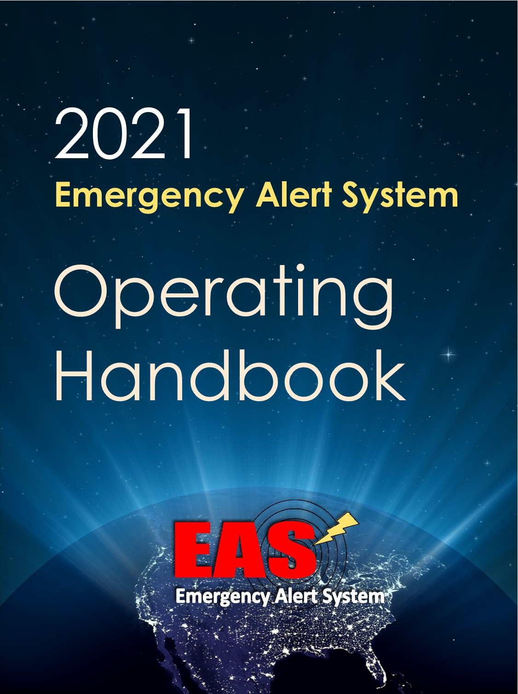

2021 EAS Operating Handbook

IMPORTANT: In order to optimize the value of the 2021 EAS Operating Handbook (2021 Handbook) for EAS Participants, the 2021 Handbook provides blank spaces in a writeable format for EAS Participants that may wish to tailor the handbook to accommodate their individual procedures. EAS Participants that tailor the 2021 Handbook may then save and print a tailored version for posting at their facility. Appropriate State or Local Emergency Communications Committee personnel and the manufacturer of your facility’s EAS device may have additional information that will assist you in utilizing this Handbook.

Operators with EAS questions or issues should contact the following individual responsible for EAS operations at this facility:

Name:

Contact Information: ___________________________________________

Post at All EAS Operator Locations
TABLE OF CONTENTS
I. Introduction 4
II. National-Level EAS Alert (47 CFR § 11.54) 6
III. Required National EAS Test (47 CFR § 11.61(a)(3)) 8
IV. Required Monthly EAS Test (47 CFR § 11.61(a)(1)) 9
V. Required Weekly EAS Test (47 CFR § 11.61(a)(2)) 11
VI. State And Local EAS Alerts (47 CFR § 11.55) 13
VII. Recovery Procedures 14

Introduction

The EAS Operating Handbook helps EAS Participant personnel handle EAS messages and tests by outlining operational procedures reflective of the requirements found in the part 11 rules (47 CFR § 11.01, et seq.). The Handbook states in summary form the actions to be taken by personnel at EAS Participant facilities upon receipt of a National-level EAS Alert, Required National, Monthly and Weekly tests, and State and Local Area alerts. A copy of the 2021 Handbook must be located at normal duty positions or EAS equipment locations. (47 CFR § 11.15.)

Guidance in this Handbook

The 2021 Handbook provides guidance on:

- National-level EAS Alert
  - This alert uses the Emergency Action Notification (EAN) event code.

- National EAS Test
  - This test uses the National Periodic Test (NPT) event code.

- Monthly EAS Test
  - This test uses the Required Monthly Test (RMT) event code.

- Weekly EAS Test
  - This test uses the Required Weekly Test (RWT) event code.

- State and Local EAS Alerts
  - These alerts use all other event codes (such as those for tornadoes and child abductions).

Instructions for Automated Facilities
If your facility operates in Automatic part of the time and Manual at other times, we recommend checking the Manual mode box. Furthermore, we recommend that you list the hours your facility is in Automatic mode when no operator intervention is required as part of Step 1 of the procedure list (e.g. "Between the hours of 1:00 am and 5:00 am on Tuesdays, no action is required.").

EAS Equipment Deployment Requirements (47 CFR §§ 11.11, 11.32-11.35)
All EAS Participants must install and deploy EAS equipment as required in the Commission’s part 11 EAS rules. Although the vast majority of EAS Participants must install and deploy an EAS encoder (see 47 CFR § 11.32) and an EAS decoder (see 47 CFR § 11.33), certain exceptions apply to Class D non-commercial educational FM, LPFM, and LPTV stations, which are not required to install and deploy an EAS Encoder, but may do so on a voluntary basis. Notwithstanding this exception, all EAS Participants, including Class D non-commercial educational FM, LPFM, and LPTV stations must install and deploy an EAS decoder. If your facility operates both an EAS encoder and decoder (Encoder/Decoder), then you should follow the general instructions in the 2021 Handbook. If your facility operates as decoder-only, you should follow the “decoder only” instructions below for Required Monthly Tests (RMT) and Required Weekly Tests (RWT).

National-Level EAS Alert (47 CFR § 11.54)

EAS Event Code: Emergency Action Notification (EAN)

All facilities are required to immediately relay the Emergency Action Notification (EAN).

The EAN is received by our EAS unit from sources outside our facility. It is generated by Federal officials.

What do I need to do if I am the operator on duty? (check one)

- At this facility, EANs are relayed automatically, with no operator intervention.
- OR -
- At this facility, the operator on duty is required to perform the following steps to relay an EAN:

- Step 1: _______________________________________________________

- Step 2: _______________________________________________________

- Step 3: _______________________________________________________

- Three short data bursts indicate that the End of Message (EOM) code has been received and that the alert will finish by itself, after which regular programming will resume.

What does the EAN sound like?

The EAN begins with the EAS Header Code (three long EAS data bursts), followed by the EAS attention signal (an 8-second tone), then the President or other authorized Federal official will speak for as long as necessary. There is no time limit to the EAN alert. The EAN will end with the EOM code (three short EAS data bursts).

There may be silence, or a repeating “please stand by” message during the EAN before the President or other authorized Federal official begins speaking.

What if I am the operator on duty and have a problem?

Note in detail what happened and immediately report the issue to the individual responsible for EAS operations at this facility.

For guidance on resolving problems, see the section on Recovery Procedures at the back of this Handbook.

Required National EAS Test (47 CFR § 11.61(a)(3))

EAS Event Code: National Periodic Test (NPT)

All facilities are required to immediately relay the NPT.

The Nationwide EAS Test is received by our EAS unit from sources outside our facility. It is generated by Federal officials.

What do I need to do if I am the operator on duty? (check one)

- At this facility, NPTs are relayed automatically, with no operator intervention.
- OR -
- At this facility, the operator on duty is required to perform the following steps to relay an NPT:

- Step 1: _______________________________________________________

- Step 2: _______________________________________________________

- Step 3: _______________________________________________________

- Three short data bursts indicate that the End of Message (EOM) code has been received, and that the test is over.

What does the NPT sound like?

The NPT consists of the EAS Header Code (three long EAS data bursts), the EAS Attention Signal (an 8-25 second tone), the test script (an audio message), and the EOM code (three short EAS data bursts).

What if I am the operator on duty and have a problem?

If the NPT test does not run, NEVER try to originate one yourself. Instead, note in detail what happened and report the issue to the individual responsible for EAS operations at this facility.

For guidance on resolving problems, see the section on Recovery Procedures at the back of this Handbook.

Required Monthly EAS Test (47 CFR § 11.61(a)(1))

EAS Event Code: Required Monthly Test (RMT)

SENDING THE RMT: Not all facilities originate RMTs. (check one)

- This facility sometimes originates RMTs. See instructions at: _______.
- OR -
- At this facility, operators should NEVER originate an RMT.

RECEIVING THE RMT: When the Monthly EAS Test is received by our EAS unit from sources outside our facility, the operator shall follow the guidance below.

What do I need to do if I am the operator on duty? (check one)

- At this facility, received RMT tests are relayed automatically, with no operator intervention.
- OR -
- At this facility, the operator on duty is required to perform the following steps to relay a received RMT:

- Step 1: _______________________________________________________

- Step 2: _______________________________________________________

- Step 3: _______________________________________________________

- Three short data bursts indicate that the End of Message (EOM) code has been received, and that the test is over.

- At this facility, the Required Monthly Test shall be run within ____minutes of being received by the EAS equipment. (Maximum time allowed between receipt and transmission is sixty (60) minutes. 47 CFR § 11.61(a)(1)).

What does the RMT sound like?

The RMT includes the EAS Header Code (three long EAS data bursts), the EAS Attention Signal (an 8-25-second tone), the test script (an audio message), and the EOM (three short EAS data bursts).

What if I am the operator on duty and have a problem?

If the RMT test does not run, do not try to originate one yourself. Instead, note in detail what happened and report the issue to the individual responsible for EAS operations at this facility.

For guidance on resolving problems, see the section on Recovery Procedures at the back of this Handbook.

Decoder-Only Required Monthly Test Instructions

FCC rule 11.61(a)(1)(i) states that, “Analog and digital Class D non-commercial educational FM, analog and digital LPFM stations, and analog and digital LPTV stations are required to transmit only the test script.” This means that analog and digital Class D non-commercial educational FM, analog and digital LPFM stations, and analog and digital LPTV stations do not have to transmit the EAS Header Code, Attention Signal or EOM for a Required Monthly Test.

Accordingly, for Required Monthly Tests, Class D NCE FM, LPFM, and LPTV stations may wish to check the box indicating “operator on duty is required to perform the following steps”, and as Step 1 fill in a statement such as, “Read the following script on the air, “This is a Required Monthly Test…”, using the appropriate script for your area as found in the State EAS Plan.

Required Weekly EAS Test (47 CFR § 11.61(a)(2))

EAS Event Code: Required Weekly Test (RWT)

- If this box is checked, our facility is exempt from originating the Required Weekly Test and all information below can be disregarded by the operator.

If the box above is not checked, all information below applies to our facility.

The EAS Required Weekly Test is originated by the EAS unit at our facility.

What do I need to do if I am the operator on duty? (check one)

- At this facility, RWT tests are originated automatically, with no operator intervention.
- OR -
- At this facility, the operator on duty is required to perform the following steps to originate an RWT:

- Step 1: _______________________________________________________

- Step 2: _______________________________________________________

- Step 3: _______________________________________________________

- Three short data bursts indicate that the End of Message (EOM) code has been received, and that the test is over.

What does the RWT sound like?

The RWT includes the EAS Header Code (three long EAS data bursts), a pause, and the EOM (three short EAS data bursts). There is NO EAS Attention Signal (8 second tone) or test script (audio message) within the RWT.

What if I am the operator on duty and have a problem?

If the RWT test does not run, note in detail what happened and immediately report the issue to the individual responsible for EAS operations at this facility so the test can be rescheduled.

For guidance on resolving problems, see the section on Recovery Procedures at the back of this Handbook.

Decoder-Only Required Weekly Test

FCC rule 11.61(a)(2)(ii) states, “DBS providers, analog and digital Class D non-commercial educational FM stations, analog and digital LPFM stations, and analog and digital LPTV stations are not required to transmit this test but must log receipt, as specified in §11.35(a) and 11.54(a)(3).”

If your facility fits within this definition, you may wish to check the box at the top of the RWT page indicating your facility is exempt from originating the RWT.

DBS providers, analog and digital Class D non-commercial educational FM stations, analog and digital LPFM stations, and analog and digital LPTV stations are otherwise required to comply with the part 11 EAS rules.

State and Local EAS Alerts (47 CFR § 11.55)

EAS Event Code: These alerts use all event codes other than those on the preceding pages.

All EAS messages, apart from a National-level EAS Alert, a National EAS Test, Required Monthly EAS Test and Required Weekly EAS Test are voluntary. Refer to your facility’s EAS State Plan as well as other State and Local alerting guidance.

Facility Notes:

__________________________________________________________________

__________________________________________________________________

__________________________________________________________________

__________________________________________________________________

__________________________________________________________________

__________________________________________________________________

Recovery Procedures

To resolve problems with any EAS event covered in this Handbook, consult the Recovery Procedures below.

At the conclusion of any EAS test or alert, if normal programming does not return or if you hear programming from another source, follow these steps:

__________________________________________________________________

__________________________________________________________________

For issues other than the one described above, follow this procedure in the order listed:

- Step 1:________________________________________________________

- Step 2:________________________________________________________

- Step 3: _______________________________________________________

- Step 4:________________________________________________________

- Step 5:________________________________________________________

- Step 6: _______________________________________________________

Note in detail what happened and immediately report the issue to the individual responsible for EAS operations at this facility.

